One Consult - Order to Consult - Radiology Consult Solution

Community Care Imaging Orders to Consult

Training Guide



March 2019

Department of Veterans Affairs

Office of Information and Technology (OI&T)

Revision History

NOTE: The revision history cycle begins once changes or enhancements are requested after the document has been baselined.

| Date | Revision | Description | Author |
| --- | --- | --- | --- |
| 03/18/2019 | 1.0 | Initial Release | AbleVets |

Table of Contents

1. Creating Community Care Consults as an Ordering Provider 1

2. Placing Imaging Orders on Hold 6

3. Placing Orders in Scheduled 8

4. Creating Community Care Consults as a Radiology Technician 10

# Creating Community Care Consults as an Ordering Provider

To create a Community Care Consult as AUTO consults to be sent directly to Community Care from Radiology Orders, follow the steps listed below:

1. Log into CPRS as an Ordering Provider.
2. From the **File** menu, select **Patient**. The **Patient Selection** dialog box displays.

Figure 1: Patient Selection Dialog Box

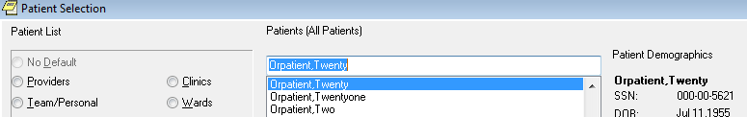

1. From the **Patients (All Patients)** drop-down menu, select a patient.
2. Click **OK**. The patient file displays.

Figure 2: Patient File in CPRS

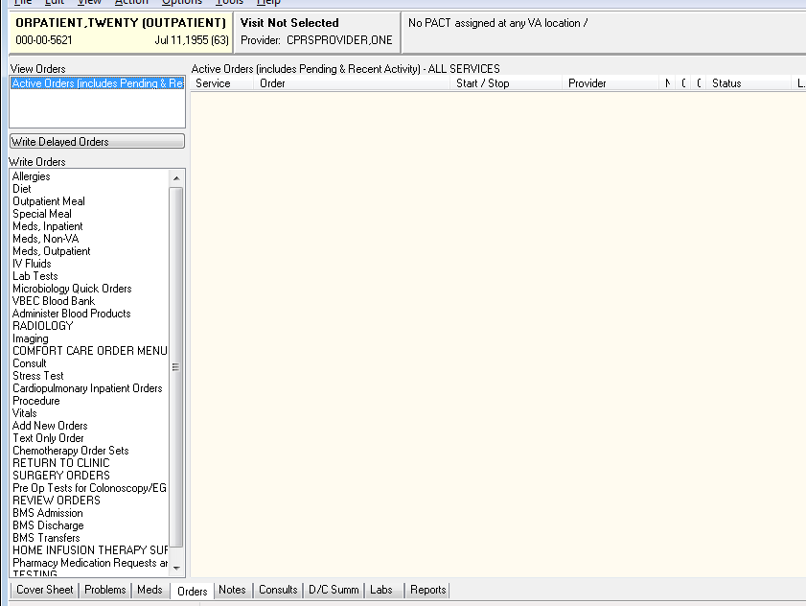

1. From the **Orders** tab, select **Imaging**. The **Location for Current Activities** dialog box displays.

Figure 3: Location for Current Activities Dialog Box

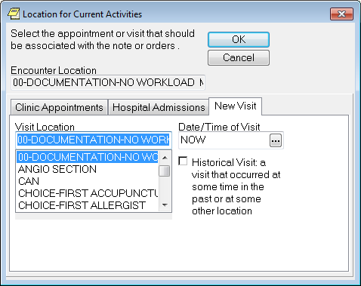

1. In the **Visit Location** field, enter a location or select from the list.
2. Click **OK**. The **Order an Imaging Procedure** dialog box displays.

Figure 4: Order an Imaging Procedure Dialog Box

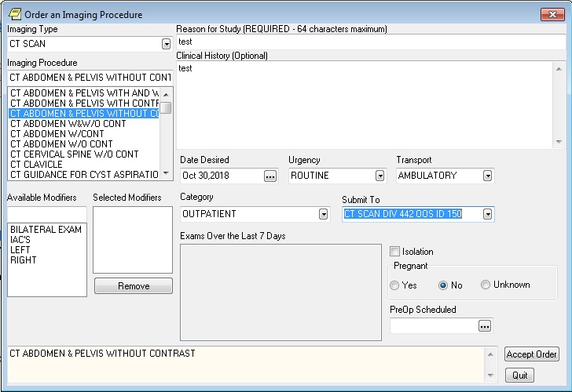

1. From the **Imaging Type** drop-down menu, select the image type.
2. Complete the remaining sections in the Imaging Procedure form.
3. Click **Accept Order** and **Quit**. The Unsigned Imaging Order displays in CPRS.
4. Do not click **Quit** if you need to order additional Imaging Procedures that will be submitted to different locations. Enter each Imaging Procedure order and click Accept Order. Once you have entered all the Imaging Procedures, then you can click **Quit**.

Figure 5: Unsigned Imaging Order in CPRS

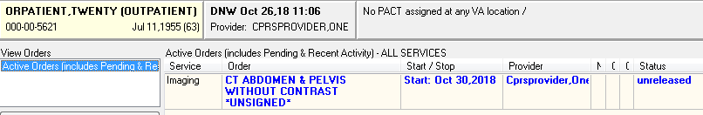

1. Right-click the imaging order(s) and sign the order(s).

Figure 6:

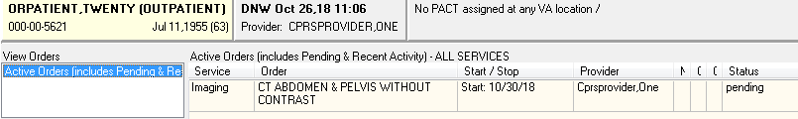

1. Double click on **Order Details**. The **Order Details** window displays.

Figure 7: Order Details Window

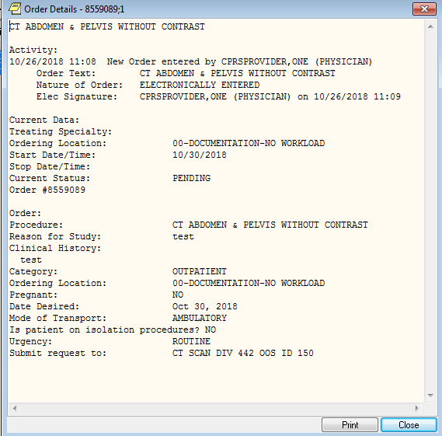

1. Click **Print** or **Close**.
2. Make two additional orders and sign them.

Figure 8: Additional Signed Orders

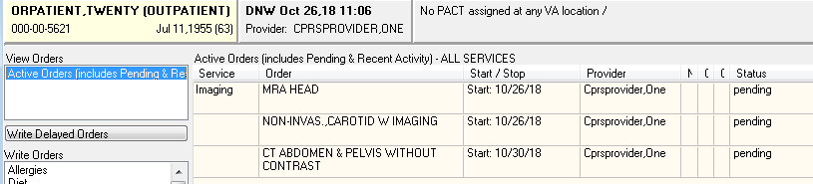

# Placing Imaging Orders on Hold

1. From the main radiology menu, select **Hold a Request**.

Figure 9: Hold a Request Menu Option

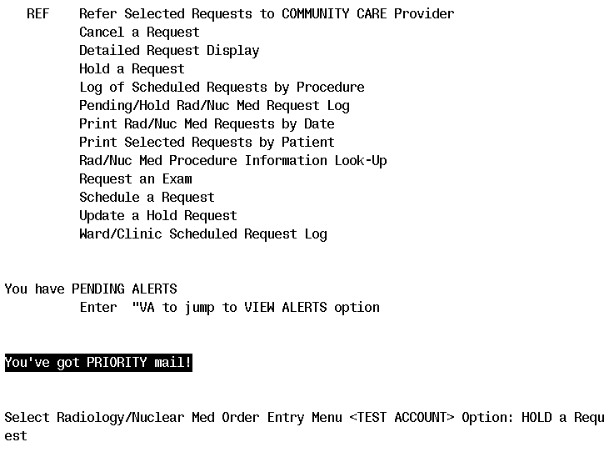

1. Select the patient that you are working on in CPRS.

Figure 10: Patient Information

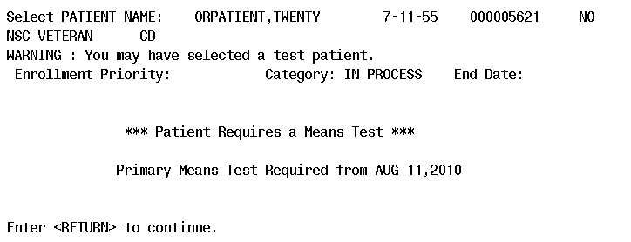

1. Select one of the orders and select a reason.

Figure 11: Selected Order

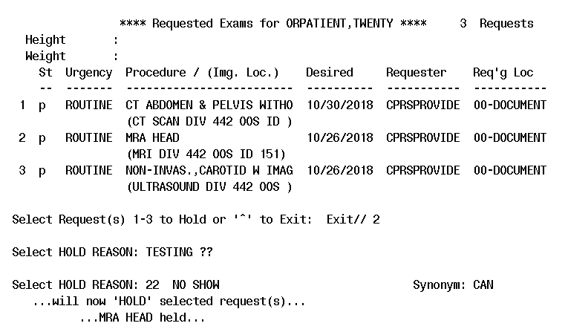

1. In CPRS, refresh the patient to show the order is now on hold.

Figure 12: Order Hold Status Displayed

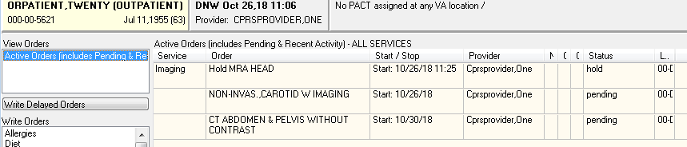

# Placing Orders in Scheduled

1. From the main radiology menu, select **Schedule a Request**.

Figure 13: Schedule a Request Menu Option

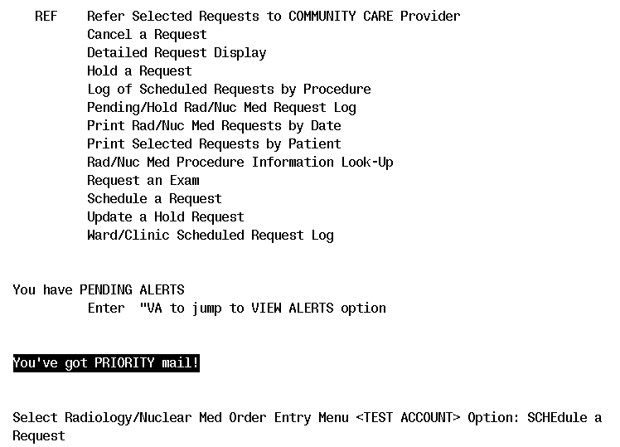

1. Select the patient that you are working on in CPRS.

Figure 14: Patient Information

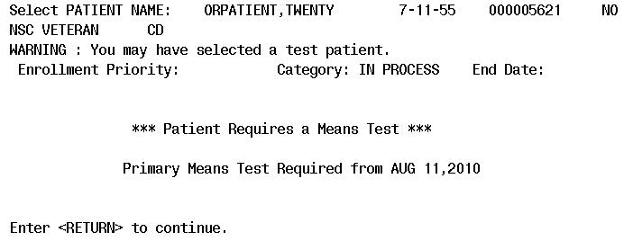

1. Select the imaging order and enter a date (and time if required).

Figure 15: Selected Order

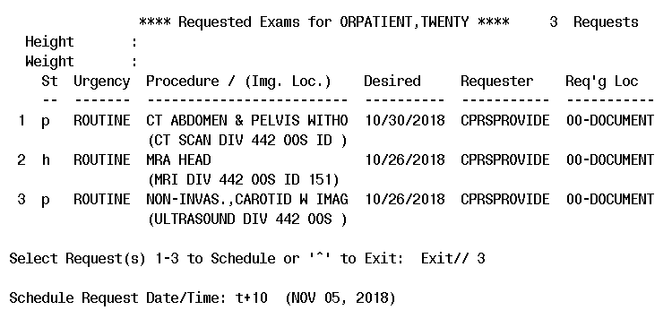

1. In CPRS, refresh the patient to show the order is now in **Scheduled** status.

Figure 16: Scheduled Status

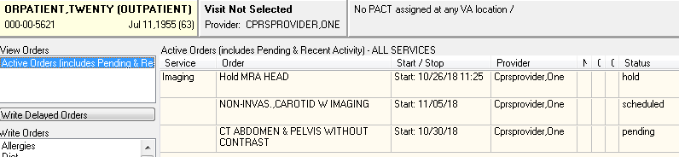

# Creating Community Care Consults as a Radiology Technician

1. Log into VistA as a Radiology Technician and, from the **Radiology/Nuclear Med Order Entry Menu**, select **REF**, and then select the patient:

Figure 17: REF Option

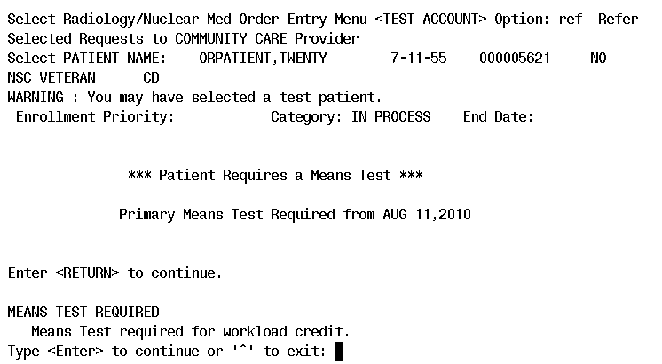

1. From the list of pending requests, select the correct procedure(s). Notice that all pending, hold, or scheduled requests, for this patient, display and are available to be referred to community care.

Figure 18: List of Pending Requests

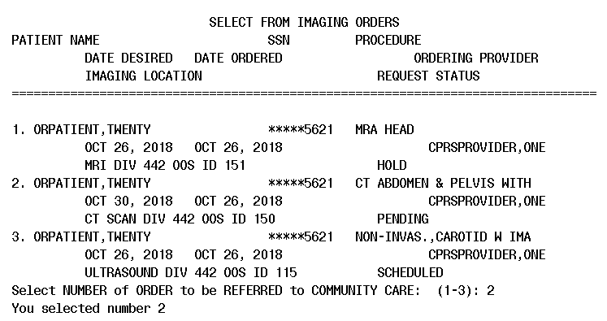

1. Select the **Justification for Community** **Care**.

Figure 19: Justification for Community Care

Select one of the following:

1 VA facility does not provide the required service

2 Veteran cannot safely travel to VA facility due to medical reason

3 Veteran cannot travel to VA facility due to geographical inaccessibility

4 VA facility cannot timely provide the required service

5 Unusual or excessive travel burden

Enter response:

1. If the sex of the patient is male and the imaging type is mammography, Mammography will automatically be the default selection within VistA. If the sex of the patient is female and the imaging type selected is mammography, you will be prompted to answer the following additional question:  
   Select one of the following   
    1. Diagnostic Mammography  
    2. Screening Mammography
2. Note that if #2 is chosen, it will ask you for a medical reason:

Figure 20: Medical Reason

Enter response: 2 Veteran cannot safely travel to VA facility due to medical reason

Medical Reason: BROKEN LEG

Consult with UCID: 442_884085 has been created

1. From the **File** menu within CPRS, select **Refresh Patient Information**.

Figure 21: Refreshed Patient Information

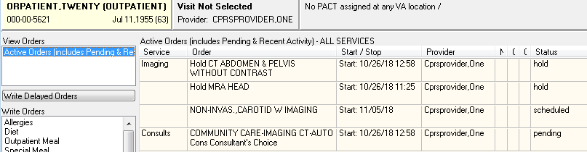

1. You can see that the imaging order that was just converted to a consult is now on hold, and a consult order has been created.
2. Navigate to the VistA roll-and-scroll and redisplay the imaging orders for the patient.

Figure 22: Imaging Orders

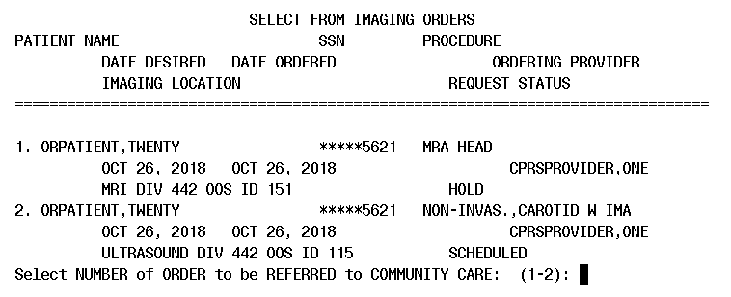

1. You can see that there are now only two orders left for conversion to consults, and the imaging order that was previously processed, and is on hold, does not show
2. Select one of the above imaging orders, and enter any **Justification for Community** **Care**.
3. Go back to CPRS and refresh the patient.

Figure 23: Refreshed Patient Information

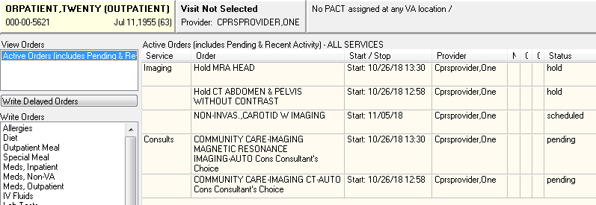

1. Repeat steps 6, 7, and 8 on the last imaging order, then refresh the patient again in CPRS.

Figure 24: Refreshed Patient Data

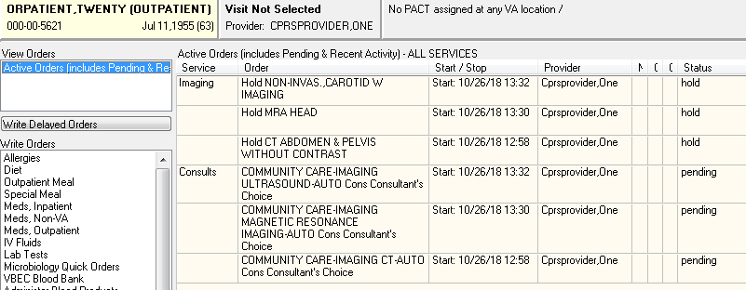

1. You can double-click on any one of the Consult orders to show details.

Figure 25: Order Details

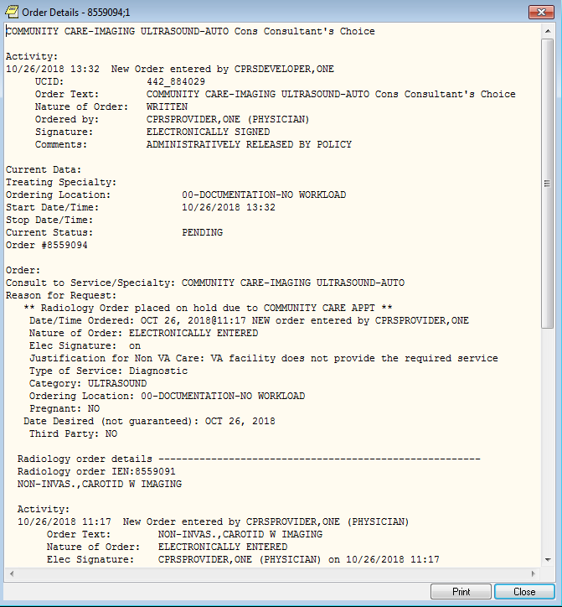

1. The original radiology order is embedded in the Consult order detail
2. Then go to the **Consults** tab and click on any consult in the left-hand panel to show the Consult Detail.

Figure 26: Consult Detail

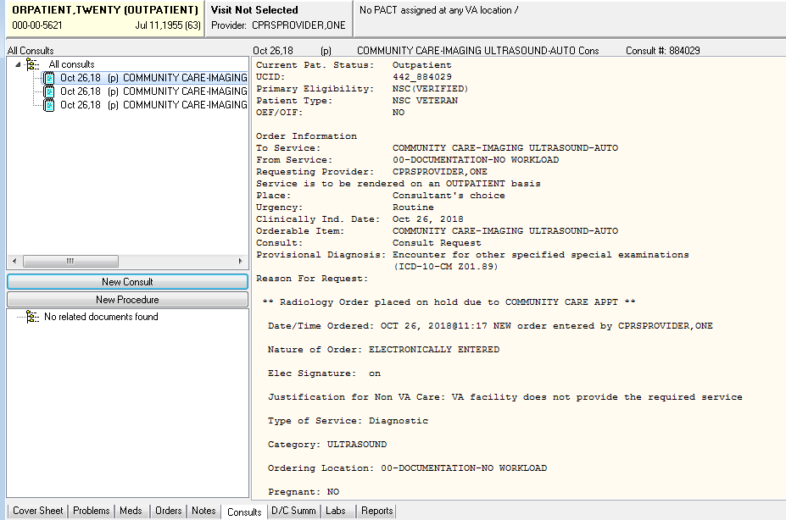

1. At the bottom of the **Consult Detail** you will see that a comment has been added which contains tags that are headed by #COI#; these are tags that are used by CDW when importing data for use in national reports.

Figure 27: Tags Displayed

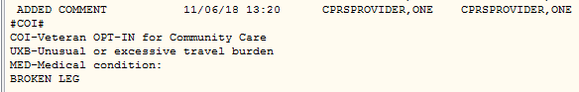

1. These CDW tags will vary depending upon the **Justification for Community Care** option chosen. The first four options on this menu give the following tags:

Figure 28: Justification for Community Care: VA facility does not provide the required service:

This screen shows the Consult detail CDW tags

Figure 29: Justification for Community Care: Veteran cannot safely travel to VA facility due to medical reason

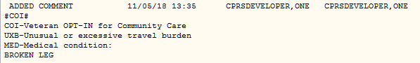

Figure 30: Justification for Community Care: Veteran cannot travel to VA facility due to geographical inaccessibility

This screen shows the Consult detail CDW tags

Figure 31: Justification for Community Care: VA facility cannot timely provide the required service

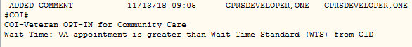

1. If **Justification for Community Care: Unusual or excessive travel burden** is chosen a sub-menu appears.

Figure 32: Sub-menu

Unusual or excessive travel burden

Select one of the following:

Unusual or excessive travel burden

Select one of the following:

1 Geographical Challenges

2 Environmental Factors

3 Medical condition

4 Nature or simplicity of services

Select Reason for Unusual or excessive travel burden: 1 - Geographical Challenges

1. The following CDW tags will then be created.

Figure 33: Geographical Challenges

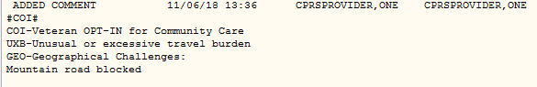

Figure 34: Environmental Factors:

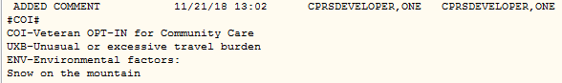

Figure 35: Medical Condition:

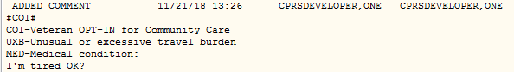

Figure 36: Nature or Simplicity of Services:

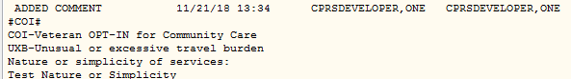

1. On any of the options above where an explanation is entered, the field can be three (3) to 240 characters in length. If the length of the text is greater than 74 characters, for it to be readable in CPRS, the text will be broken down into two (2) or more lines. The text will be broken on a word, never in the middle of a word. Below is an example of the output:

Justification for Community Care:

Veteran cannot safely travel to VA facility due to medical reason

The patient fell downstairs and broke his leg. He is currently using

crutches to get around, but he is unable to get into a vehicle. Etc,

etc, etc, etc, etc, etc, etc, etc.

Comment and CDW tag:

#COI#

COI-Veteran OPT-IN for Community Care

Veteran cannot safely travel to VA facility due to medical reason

The patient fell downstairs and broke his leg. He is currently using

crutches to get around, but he is unable to get into a vehicle. Etc, etc,

etc, etc, etc, etc, etc, etc.

Figure 37: Order Details

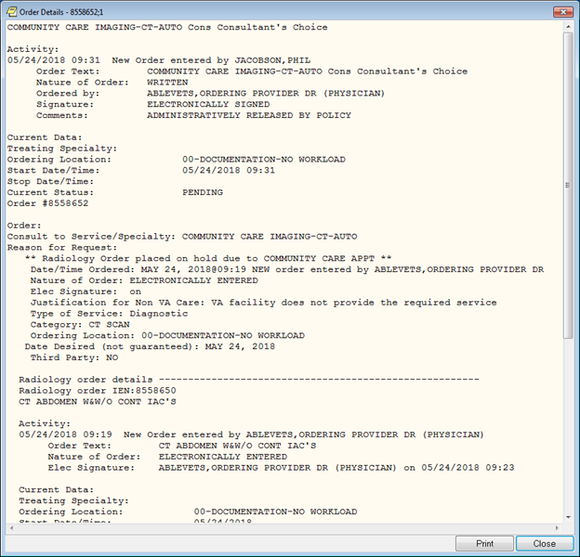

1. Click **Print** or **Close**.